Instructions for attending an online lecture on Google Meet

- Log into your Gmail account.
- Click the „9 dots” icon in the upper right corner and select „Calendar” from the list.

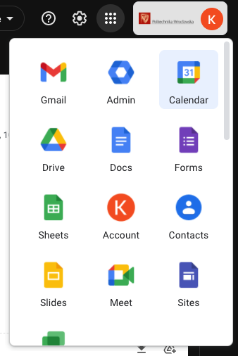

- The calendar opens in a separate browser tab. You must select the target event.

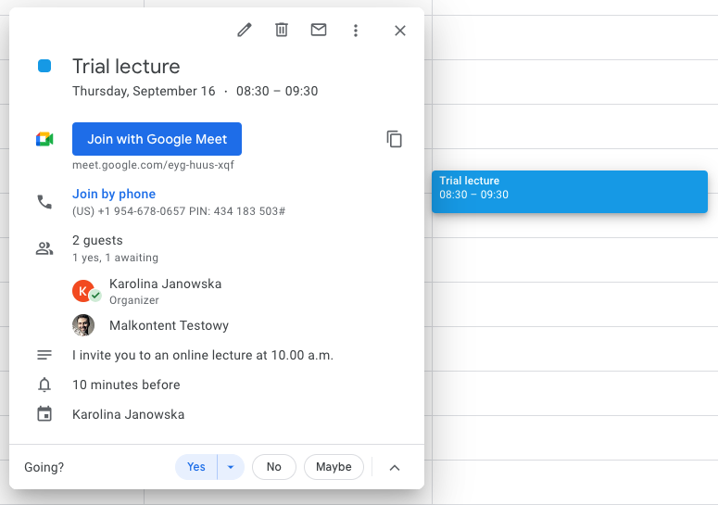

Attention: from the window above you can:
- Edit an event,
- Cancel it,
- Send a message to the paricipants again,
- More options: duplicate the event, delegate hosting of the event, etc.

- The "waiting room" will open in a new tab of your browser, in which you can check the availability of the camera and microphone and join the meeting with Google Meet.
In the lower left corner of the black screen, you can adjust the background.
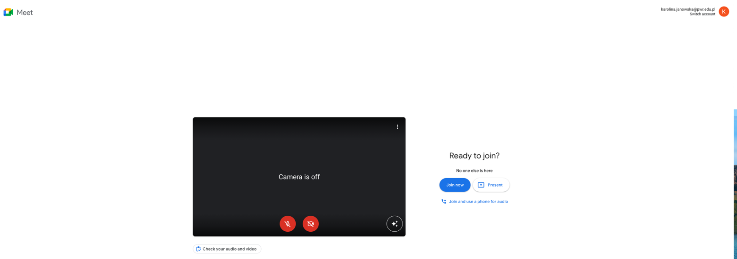

- A chat window appears. On the bottom bar on the left:
  - Time and name of the event
  - Microphone
  - Camera
  - Rise a hand/put your hand down – the equivalent of raising a hand in class,
  - Present now:
    - The whole screen – share everything,
    - A window – share only a chosen file, e.g. presentation (that needs to be opened earlier),
    - A tab – share a tab of your browser.
  - More options:
    - Board – you can use Jamboard,
    - Change layout - change the layout of the tiles,
    - Full screen - full screen view of the meeting,
    - Change background,
    - Subtitles,
    - Report a problem/Report abuse,
    - Help,
    - Settings – if you use a different microphone or screen, you can select it in the settings.
  - Leave the meeting,
  - Meeting details – in addition to information about this event, the attachment placed in the event description will also appear here,
  - Participants – the list of participants of the event. The event host can moderate the meeting, e.g. mute the microphones, block the chat, disable participant’s presentation, etc.
  - Chat,
  - Actions – turning on the virtual board,
  - Host settings.

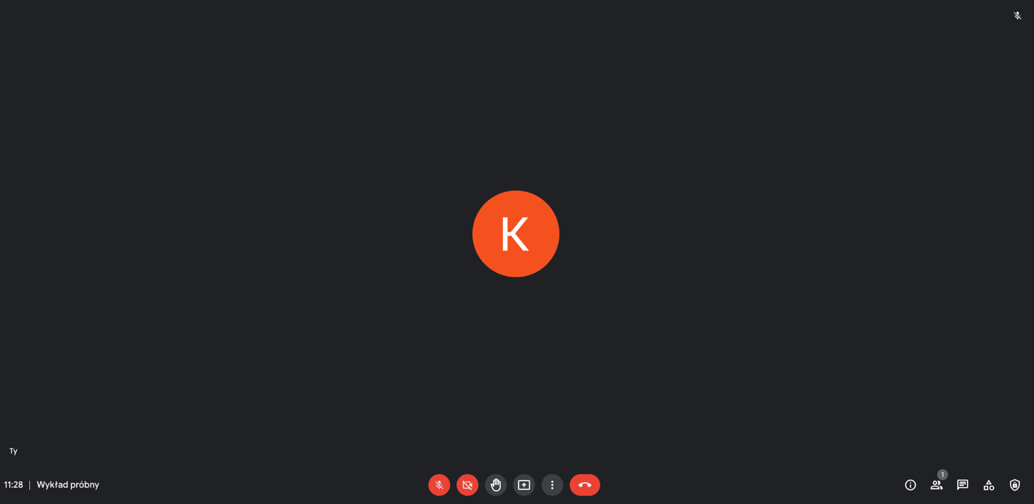
b c d e f g h i j k l
a

